**PHENIKAA UNIVERSITY**

FACULTY OF ELECTRICAL AND ELECTRONIC ENGINEERING

**MICROPROCESSOR AND MICROCONTROLLER ENGINEERING FINAL REPORT**

**Topic:** Secure Entryway Management System - SEMS

**Students**: Dương Doãn Tùng

Nguyễn Trọng Huy Hoàng

**Class**: K15-AI&RB

**Course**: Kỹ thuật vi xử lý và vi điều khiển-1-2-22(AIR05)

**Instructor**: Huỳnh Bá Phúc

**HA NOI, 4/2023**

# TASK & DIVISION OF WORK

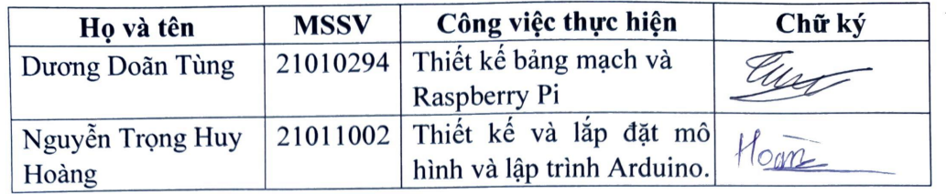

Contents

TASK & DIVISION OF WORK 2

I. ABSTRACT 1

II. INTRODUCTION 1

III. PROBLEM DEFINITION AND PROPOSED SOLUTIONS 2

IV. THEORETICAL AND PRACTICAL EXPLANATIONS 2

V. DESIGN AND IMPLEMENTATION 5

1. Hardware design 5

# ABSTRACT

The topic of our project is to create a model door that can be controlled by an Arduino and integrated with facial recognition feature using Raspberry Pi. This model door is designed to be opened or closed by using a push button, and users can enter a password to open the door using a control keypad. When the password is entered correctly, the door will open and the LCD screen outside will display the entered password. Additionally, to ensure the safety and security of the door, we have added the facial recognition feature using Raspberry Pi. This will help users to open the door by recognizing their face instead of entering a password every time. To achieve this, we use the IR camera on Raspberry Pi to recognize and transmit information to the Arduino via UART communication protocol.

# INTRODUCTION

The project consists of two main functions: unlocking the door by password and unlocking the door by face recognition. The user can enter a password using a 4x4 matrix keyboard, and the password will be displayed on a 16x2 LCD screen with asterisks. If the password is correct, the door will open.

The face recognition function uses an IR camera on Raspberry Pi to detect and identify the user's face. If the face matches one of the registered faces in the database, the Raspberry Pi will send a signal to Arduino via UART communication protocol to open the door. The name of the recognized user will also be shown on the LCD screen.

The project was completed by following these steps:

1. designing the circuit diagram and layout of the model door;
2. programming the Arduino and Raspberry Pi using C++ and Python languages; 3) testing and debugging the code and hardware;
3. evaluating the performance and accuracy of the system;
4. writing the project report and preparing the presentation.

The project faced some challenges, such as:

1. finding suitable components and materials for the model door;
2. ensuring reliable communication between Arduino and Raspberry Pi;
3. improving the speed and accuracy of face recognition;
4. dealing with environmental factors such as lighting.

The project provides a practical example of how Arduino and Raspberry Pi can be used to create a smart home device that can improve the security and convenience of users. The project also demonstrates the skills and knowledge of electronics, programming, and engineering that we have learned during our course.

# PROBLEM DEFINITION AND PROPOSED SOLUTIONS

The problem that our project aims to address is how to design and implement a model door that can be controlled by Arduino and integrated with face recognition feature by Raspberry Pi. This problem is relevant for applications that require high security and convenience for users, such as smart homes, offices, or hotels. The problem is also challenging because it involves combining different hardware and software components, such as sensors, cameras, LCD screens, keyboards, Arduino boards, Raspberry Pi boards, and communication protocols. The problem has not been fully solved by existing solutions, which either rely on only one method of unlocking (such as password or face recognition) or are too complex and expensive to implement. Therefore, our project aims to provide a simple, low-cost, and effective solution that can demonstrate how to use Arduino and Raspberry Pi to control a model door with both password and face recognition features.

# THEORETICAL AND PRACTICAL EXPLANATIONS

The system consists of two main components: an Arduino board and a Raspberry Pi board. The Arduino board is responsible for controlling the door lock mechanism, displaying text on the LCD screen, reading input from the keypad and the button, and communicating with the Raspberry Pi board via UART protocol. The Raspberry Pi board is responsible for performing face recognition, checking password validity, and handling the admin panel.

The Arduino board is connected to a 4x4 matrix keypad, a 16x2 LCD screen, a button, 2 LED and a stepper motor. The keypad allows the user to enter a password, which will be displayed on the LCD screen with asterisks. The stepper motor acts as a door hinge. The button can be used to open the door from inside.

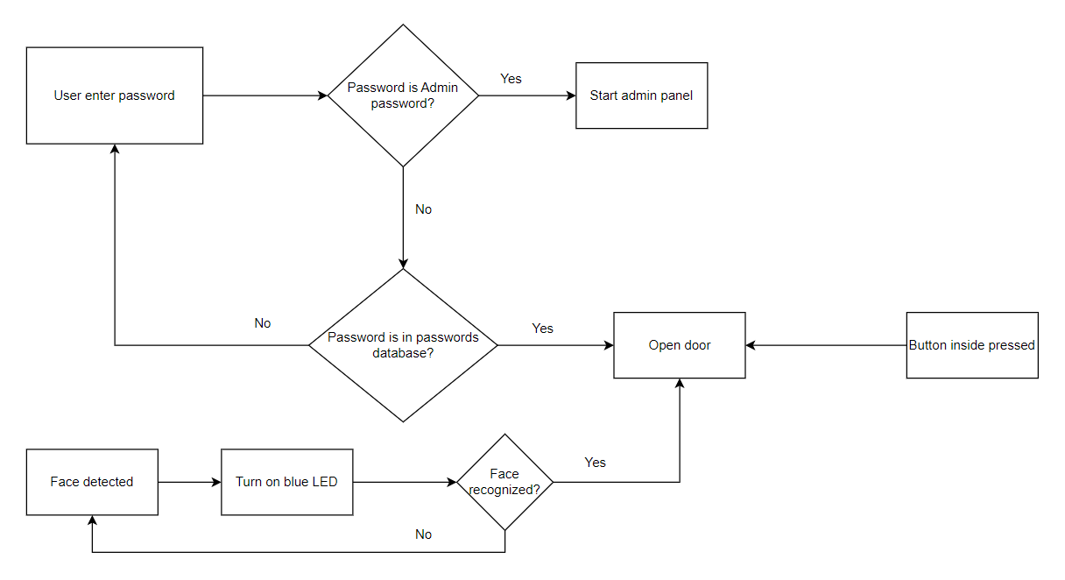

Diagram . 3 Ways to open the door

The Raspberry Pi board is connected to an IR camera that can capture images of the user's face. The Raspberry Pi board uses OpenCV library to detect and identify faces using a pre-trained classifier. The classifier compares the captured face with the registered faces in the database and returns the name of the matched user. The Raspberry Pi board also has an admin panel that allows the user to register new faces, delete existing faces, or change passwords, which can be accessed from the keypad.

The communication between the Arduino board and the Raspberry Pi board is done using UART protocol. UART stands for Universal Asynchronous Receiver/Transmitter, which is a serial communication method that uses two wires: TX (transmit) and RX (receive). The Arduino board sends data to the Raspberry Pi board using its TX pin, and receives data from the Raspberry Pi board using its RX pin. The data is sent and received in bytes, which are encoded using ASCII characters.

The system works as follows:

- When the system is powered on, it enters password mode by default. The LCD screen displays "*Enter Password:*" and waits for user input.

- The user can enter a password using the keypad. The password will be displayed on the LCD screen with asterisks, which can be changed in the admin panel.

- The Arduino board sends the password to the Raspberry Pi board using UART protocol.

- The Raspberry Pi board checks if the password is valid by comparing it with the stored passwords in the database.

- If the password is valid, the Raspberry Pi board sends open door command to the Arduino board using UART protocol.

- During the opening and closing phases of the door, the red LED will turn on to indicate its status. Once the door has completed its action, the LED will automatically turn off.

- The Arduino board receives the command and activates the stepper motor, which turns the door and open it. The LCD screen displays "*Access granted*" for 20 seconds, then returns to "*Enter Password:*".

-The user can use the face recognition mode by simply looking at the IR camera. When a face is detected in frame, the blue LED lights up to indicate that a face has been detected.

- The Raspberry Pi board uses OpenCV library to detect and identify faces using a pre-trained classifier.

- If a face is detected and matched with one of the registered faces in the database, the Raspberry Pi board automatically send open door command, followed by the name of the recognized user to the Arduino board using UART protocol.

- The Arduino board then unlocks the door. The LCD screen displays "*Access granted:* *[name]* " for 20 seconds, then returns to "*Enter Password:*".

- The user can access the admin panel by entering a special password (default is 0301011). This password can be changed by the user in the admin panel.

# DESIGN AND IMPLEMENTATION

## Hardware design

Figure . Circuit design